shell & syn

**INTEGRATIVE BODY-THERAPY**

**303 Fifth Ave. (31st St), Suite 1913, New York, NY, 10016 Tel & Text: 212-683-9600**

**www.SynchronicityMassage.com**

*INFORMATION FOR MASSAGE THERAPY*

Please answer the following questions so that we may have a better understanding of your general health and lifestyle to enable us to custom-design your treatment. All information is strictly confidential.

**P L E A S E P R I N T**

|  |  |  |  |  |  |  |  |  |
| --- | --- | --- | --- | --- | --- | --- | --- | --- |
| Last  Name: |  | First  Name |  | Middle  Initial |  | Date  of birth: |  | **▢** Male  **▢** Female |

|  |  |  |  |
| --- | --- | --- | --- |
| Home Address: |  | Zip Code: |  |

|  |  |  |  |  |  |
| --- | --- | --- | --- | --- | --- |
| Home  Phone: |  | Work  Phone: |  | Mobile  Phone: |  |

|  |  |  |  |  |  |
| --- | --- | --- | --- | --- | --- |
| Marital  Status: |  | Referred  By: |  | Email: |  |

|  |  |  |  |  |  |  |  |
| --- | --- | --- | --- | --- | --- | --- | --- |
| Height: |  | Weight: |  | BMI:  (Off.Use) | . .  . . | Average amount of water you drink daily: | (oz) |

|  |  |
| --- | --- |
| Primary reason for  massage therapy: |  |

|  |  |  |  |
| --- | --- | --- | --- |
| If in pain, how often  does it hurt? Where? |  | Intensity of pain from 1 to 10:  (“10” is unbearable) |  |

|  |  |
| --- | --- |
| What relieves the pain? |  |

Healthcare professionals (MDs, Chiropractors, etc) you have consulted for the above discomfort? Please list types of treatments with dates:

|  |
| --- |
|  |
|  |
|  |

History of injuries, illnesses and/or surgeries with dates:

|  |
| --- |
|  |
|  |
|  |
|  |

Medications you are currently taking and for which condition:

|  |  |  |  |
| --- | --- | --- | --- |
| Medication | For Treatment Of | Dose/Amt. per day | Effectiveness |
|  |  |  |  |
|  |  |  |  |
|  |  |  |  |
|  |  |  |  |
|  |  |  |  |

|  |  |
| --- | --- |
| Supplements you are currently taking: |  |
|  | |

|  |  |  |  |
| --- | --- | --- | --- |
| Current  Occupation: |  | Past  Occupation(s): |  |

|  |  |  |  |
| --- | --- | --- | --- |
| Regular physical activities  or sports? How often? |  | Hobbies: |  |

|  |  |  |  |  |  |
| --- | --- | --- | --- | --- | --- |
| Are you pregnant? | **▢**YES **▢** NO | If yes, due date: |  | Do you have any children? |  |

|  |  |  |  |
| --- | --- | --- | --- |
| Your Physician  Name and Phone: |  | Your Specialist  Name and Phone: |  |

|  |  |
| --- | --- |
| Emergency contact (name and phone): |  |

**GENERAL MEDICAL HISTORY (please highlight)**

**CARDIOVASCULAR**

* Chronic congestive heart failure
* Family history of cardiovascular problems
* Heart attack
* Heart disease
* Hemophilia
* High blood pressure
* Low blood pressure
* Pacemaker
* Phlebitis / varicose veins
* Poor circulation
* Stroke

**DIGESTIVE SYSTEM**

* Cholesterol, elevated
* Colitis
* IBS / IBD
* Stomach ulcer

**HEAD & NECK**

* Headaches/migraines
* Hearing loss
* Ringing in ears
* Vertigo/dizziness
* Vision loss
* Vision problems

**INFECTIONS**

* Hepatitis
* Herpes
* HIV / AIDS
* Infectious skin conditions
* Lyme disease
* Tuberculosis

**MUSCULOSKELETAL**

* Bursitis
* Carpal tunnel
* Family history of arthritis
* Heel spur/plantar fasciitis
* Hernia
* Jaw pain (TMJ)
* Osteoarthritis
* Osteoporosis
* Pins / plates/ wires / artificial joints
* Sciatica
* Scoliosis
* Sprains (joint)
* Strain (muscle)
* Tendonitis
* Whiplash

**NERVOUS SYSTEM**

* Epilepsy
* Multiple sclerosis
* Numbness/tingling
* Paralysis
* Parkinson’s disease
* Sciatica
* Seizures
* Sensory loss/change
* Vertigo

**RESPIRATORY**

* Asthma
* Bronchitis
* Chronic cough
* Emphysema
* Family history of respiratory disease
* Frequent colds
* Pneumonia
* Shortness of breath
* Sinusitis
* Smoker

**REPRODUCTIVE**

* C-section delivery
* Gynecological problems
* Low libido
* Pelvic pain

**OTHER CONDITIONS**

* Anxiety
* Cancer
* Chronic fatigue syndrome
* Dental problems
* Depression
* Diabetes
* Drug addiction
* Eating disorder
* Fibromyalgia
* Hormone imbalance
* Hyperglycemia
* Hypoglycemia
* Incontinence
* Kidney /bladder disease
* Liver/gallbladder disease
* Lymphadenectomy
* Motor vehicle accident
* Psychiatric problems
* Radiation treatment
* Scars
* Unexplained weight loss
* Vaccinations:
* Influenza
* Covid19
* Shingles
* Others:

|  |  |
| --- | --- |
| **OTHERS:** |  |

**Do you have any of the following TODAY? Please highlight all that applies.**

|  |  |  |  |
| --- | --- | --- | --- |
| Bruises | Cold / Flu / Fever | Irritated skin rash | Open cuts / infection |
| Burns (sun or radiation) | Headache | Inflammation | Poison ivy/oak |

**Please circle the areas of concern on the diagram:**

R. L. L. R. L. R.

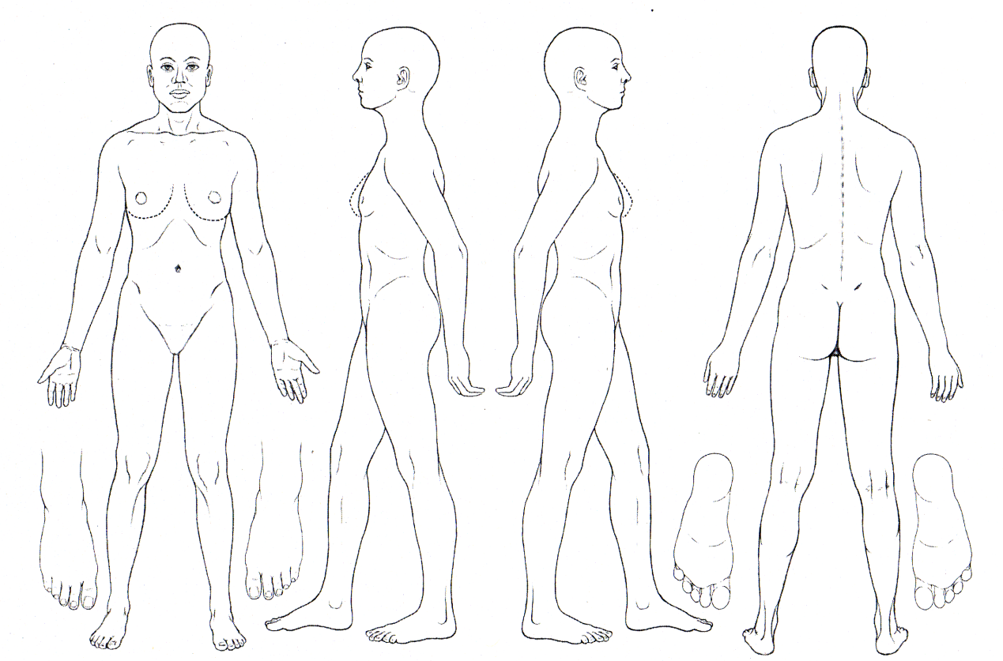

shell & syn

**INTEGRATIVE BODY-THERAPY**

**303 Fifth Ave. (31st St), Suite 1913, New York, NY, 10016 Tel & Text: 212-683-9600**

**www.SynchronicityMassage.com**

***Lateness and Cancellation***

We greatly appreciate your consideration and cooperation of the following policy.

* Lateness. The client is financially responsible for the entirety of the scheduled appointment.
* Cancellation/Reschedule. Charges will be made for appointments cancelled or broken with less than 24-hour advanced notice. First infraction is 50% of the session fee. A full visit fee for subsequent happening.

To notify us: call or text (212) 683-9600.

***Payment***

* Payment must be received at the time of the appointment in cash, check, Zelle or PayPal
* Pay by PayPal: 3.5% transaction fee will be added to the charge.
* We do not accept credit card payment
* Returned check fee: up to $35 per check
* Upon request, we will provide you a receipt with insurance code for your insurance submission

***PLEASE READ AND SIGN:***

It is my choice to receive massage therapy. I am aware of the benefits and risks of massage and give my consent for massage. I understand that there is no implied or stated guarantee of success of effectiveness of individual techniques or series of appointments. I acknowledge that massage therapy is not a substitute for medical care, medical examination or diagnosis. I have started all medical conditions that I am aware of and will inform my practitioner of any changes in my health status.

I understand that my personal health information will be collected. I understand that all information that I provide will be kept confidential unless required by law. I understand and consent that my medical information may be shared by the various care providers in my care and treatment.

Treatments may be covered by extended health care plans. I understand that it is my responsibility to confirm the exact details of my coverage.

I understand that if I cancel an appointment with less than 24 hours advanced notice, I will be responsible for the payment for the scheduled session time.

|  |  |  |  |  |
| --- | --- | --- | --- | --- |
| **Print Name**: |  |  | **Date:** |  |

|  |  |  |
| --- | --- | --- |
| **Signature**: |  |  |

V24.12